.Assignment 4 Part 2: Advanced Queries, Joins & Views

QUERIES

1. *List all users who currently have an item being shipped from oldest to newest shipments(tracking numbers)*

SELECT u.user_id, user_name, s.shipping_tracking

FROM shipping s, users u, sold i

WHERE s.shipping_tracking > 0

AND s.user_id = u.user_id

AND s.shipping_tracking= i.shipping_tracking

ORDER BY shipping_tracking ASC;

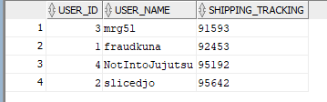

2. *List all of the auctions one user has put up*

SELECT a.user_id, a.item_id, i.item_name

FROM auctions a, users u, items i

WHERE user_id=4

AND a.user_id = u.user_id

AND a.item_id = i.item_id

ORDER BY item_id ASC;

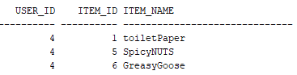

3. *List of items that have been bid on in the past 3 days, hence the most popular.*  
SELECT a.item_id, a.auction_latest, i.item_endDate, b.bids_top

FROM auctions a, bids b, items i

WHERE a.auction_latest >= SYSDATE - 4

AND a.auction_latest <= SYSDATE

AND a.item_id = i.item_id

AND b.item_id = i.item_id

ORDER BY a.auction_latest DESC;

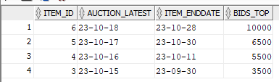

VIEWS

1. *The total amount of bids a user has on an item*

CREATE VIEW BiddingActivity AS

(SELECT u.user_id, COUNT(b.item_id) AS total_bids

FROM pastbids b, users u

WHERE b.item_id=1

AND u.user_id = b.user_id

GROUP BY u.user_id

);

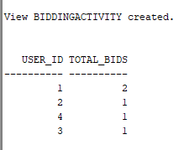

2. *Get the first ten user accounts created inclusive, and create a view with their id number, username, and name*  
CREATE VIEW FirstTenUsers (FT_UserID, FT_Name, FT_Username) AS

(SELECT user_id, user_name, user_username

FROM users

WHERE user_id <= 10

);

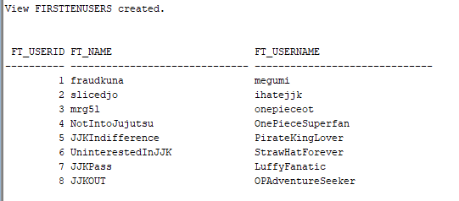

3. *Get the users that have a financial card that expires within 10 days.*

CREATE VIEW ExpireSoon (ES_UserID, ES_Expiry) AS

(SELECT user_id, finance_expiry

FROM finance

WHERE finance_expiry > SYSDATE AND finance_expiry <= SYSDATE + 10

);

